VIEWING AND RESPONSES
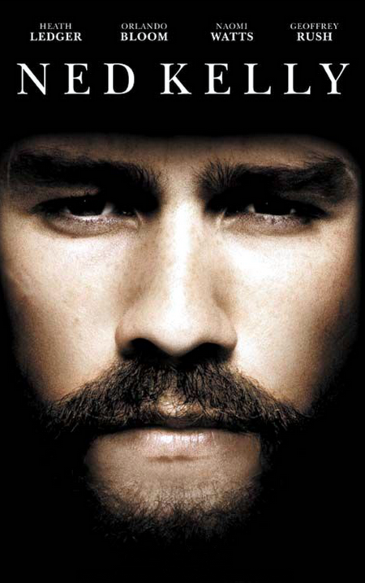

NAME:_______________________________
BEFORE

ON-LINE SCAVENGER HUNT
Find online images of the following objects, copy them and write a reference and a short caption for each image, explaining how it represents Ned Kelly.

  - an Australian tourist souvenir featuring Ned Kelly
  - an image which shows Ned as a villain
  - an image which shows Ned as a hero
  - a place connected to him
  - an historic object in a museum relating to him
  - a death image
  - an artwork
  - an everyday object featuring Ned Kelly.

DURING
Complete individual responses. (Pause the film at intervals or re-view)

OPENING SEQUENCE
- What impressions of Ned Kelly’s character is created in the opening minutes of the film? Consider the way that he speaks to the runaway horse, and his words and actions in the altercation with Constable Hall.

- Identify three further scenes in which the initial impressions are reinforced and explain how this is achieved.

FAMILY SCENES
- How are scenes that involve Ned’s family used to soften his image? Give at least two examples.

NED IS ATTACKED BY THE POLICE
- One of the key themes in the film is the notion that the Kellys were led into crime by the oppression that they suffered at the hands of the police. Identify three scenes where this is apparent. Give specific examples of techniques and explain how they were used to create this impression.

FEMALE CHARACTERS
- Identify and describe three situations in which gang members were assisted, or their crimes were made to seem less bad, because women were involved.

FITZPATRICK INCIDENTS
- Several scenes show us aspects of Constable Fitzpatrick, including the key moment in Kelly’s life where Fitzpatrick accuses Ned of shooting him at the family’s home. This was the moment that changed Ned Kelly from a typical selector’s son into an outlaw. How does the film present Fitzpatrick’s relationship with Ned?

STRINGYBARK KILLINGS
- How does the film present the Stringybark murders so that your sympathies are with Ned rather then the police?

BANK ROBBERY AT JERILDERIE
- Why did Ned insist that Steve Hart return the watch?

SIEGE AT GLENROWAN
- How does the film present the gang’s behavior during the siege? Give examples and explain what values and attitudes are represented.

Examples | Values and attitudes shown

SYMBOLS
- There is strong symbolism in some of the images used in the film. Comment on the significance of each of the following:

Symbol | Significance or meaning
Recurring scenes of birds
Watches
Blood
Bushfire ravaged country
Green and gold sash
Lion

AFTER
Reflect on your understanding of the film, completing opinionative responses.

- Unlike most other bushrangers, Ned Kelly is known and recognised by the majority of Australians. (you could test this statement by carrying out a survey.) What is so distinctive, special or memorable about Ned Kelly in Australian history? Explain why you think Australians have a continuing fascination with the Ned Kelly story.

- The film aims to present a portrait of Ned. How does the film explain Ned – what does it tell us about what drove Ned Kelly? Was it ambition? Pride? Bravery? Family? Mateship? A sense of injustice?
Give your opinion as to Ned’s motivating forces and explain your ideas.

- This film is based on the novel Our Sunshine by Robert Drewe. The novel opens with the scene of the caged lion at the Glenrowan siege. The film originally opened with this scene but it was changed to show the drowning boy. Discuss the strengths and weaknesses of each of these opening scenes.

- How effective is the technique of using Ned’s voice-over to move the narrative along? Explain the role that this plays in shaping the sympathies of the viewer.

- If the Kelly gang were on the run today, following the murder of three policemen, how would the media deal with the story? Explain how you think newspapers, tv current affairs, talkback radio and social media might deal with the crimes of the Kelly gang.

